The Power of Christ before and during His crucifixion:
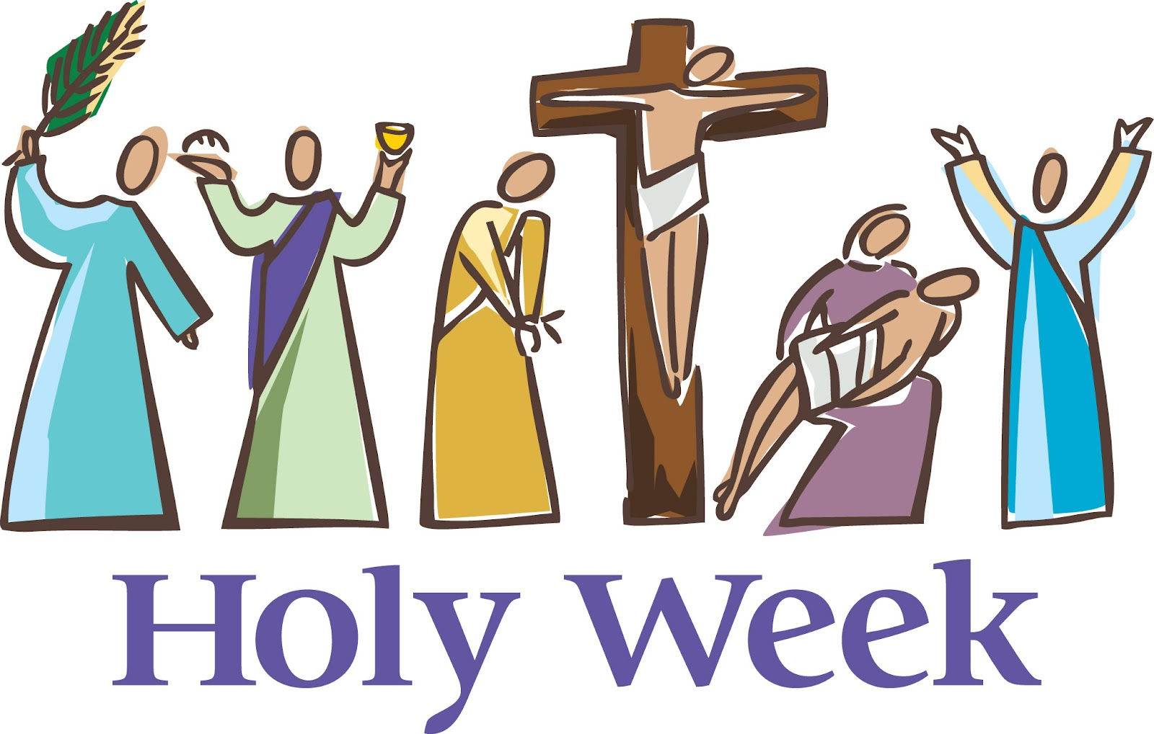

What is the most part you like about the holy week?
What is the best hymn you love during the holy week?
Mine is………………………….

"Thine is the Power, the Glory, the Blessing and the Majesty, forever Amen, Emmanuel our
God and our King "

"Thine is the Power, the Glory, the Blessing and the Majesty, forever Amen, Our Lord
Jesus Christ",

"Thine is the Power, the Glory, the Blessing and the Majesty, forever Amen ...”

Why we repeat that?
In each of these prayers, we turn to our God and Savior in His passions and say, "we know who You are, for "Thine is the Power, Glory, Blessing and Honor, forever Amen."

So let us follow Jesus in the holy week step by step and see, how He showed His power through……..

The day | What happened | How the power of our Lord is shown
Palm Sunday | 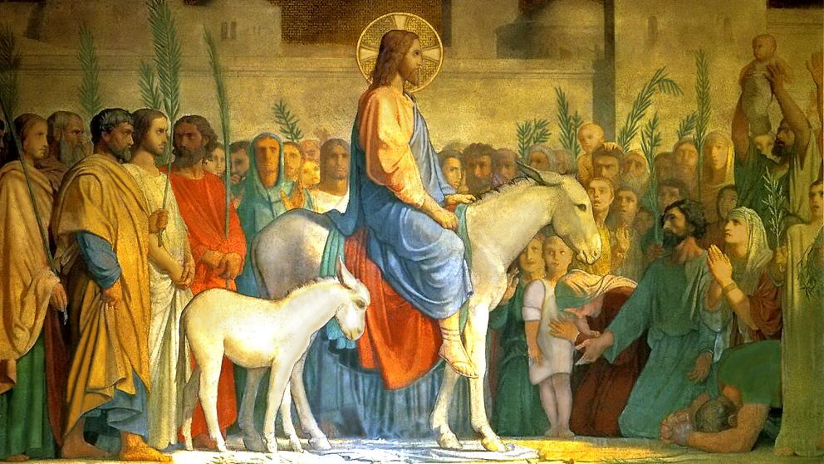 | - Humbleness  - Entering as a king
Monday | 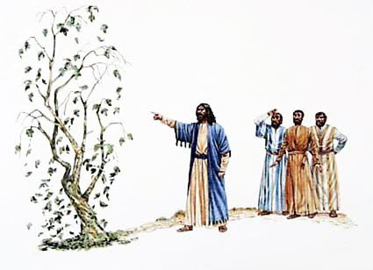  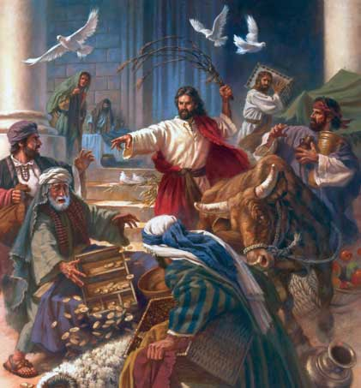 | - Power of judgment.  - Knowing of the heart, not appearances.  - Authority in the house of God
Tuesday | 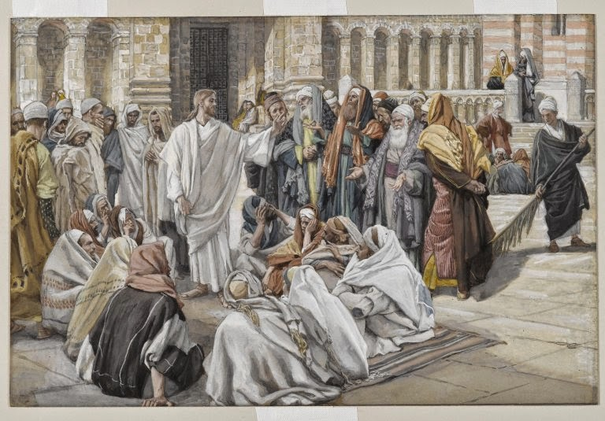  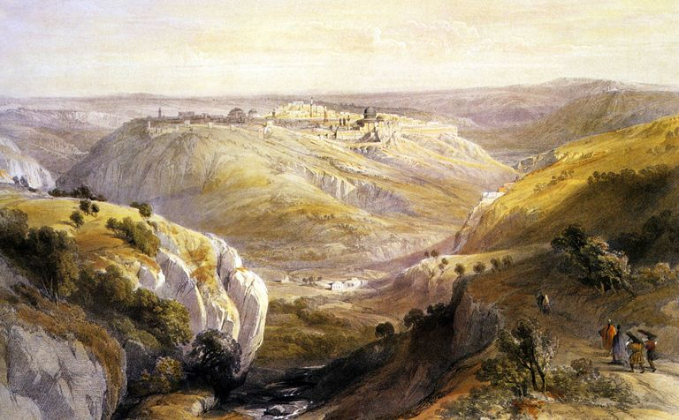 | - Wisdom in answering the questions of the religious leaders.  - Discourse of the destruction of the temple, the second coming, and parables about being ready for the second coming.
Wednesday | 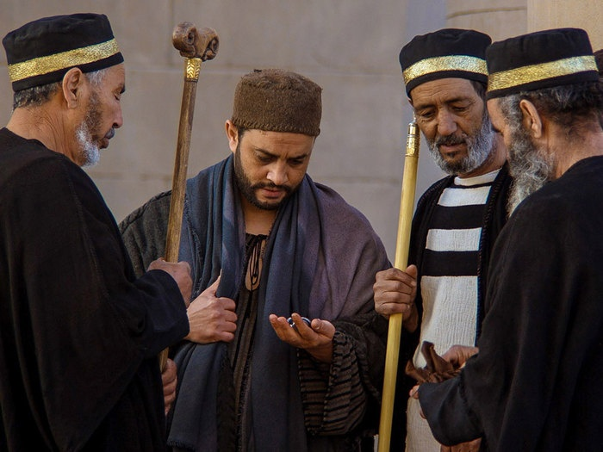
Thursday | 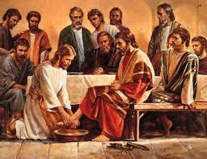  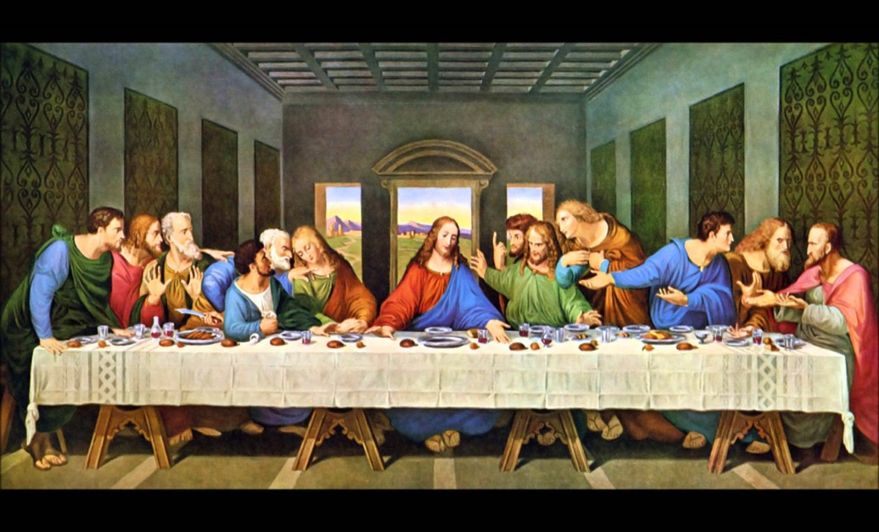  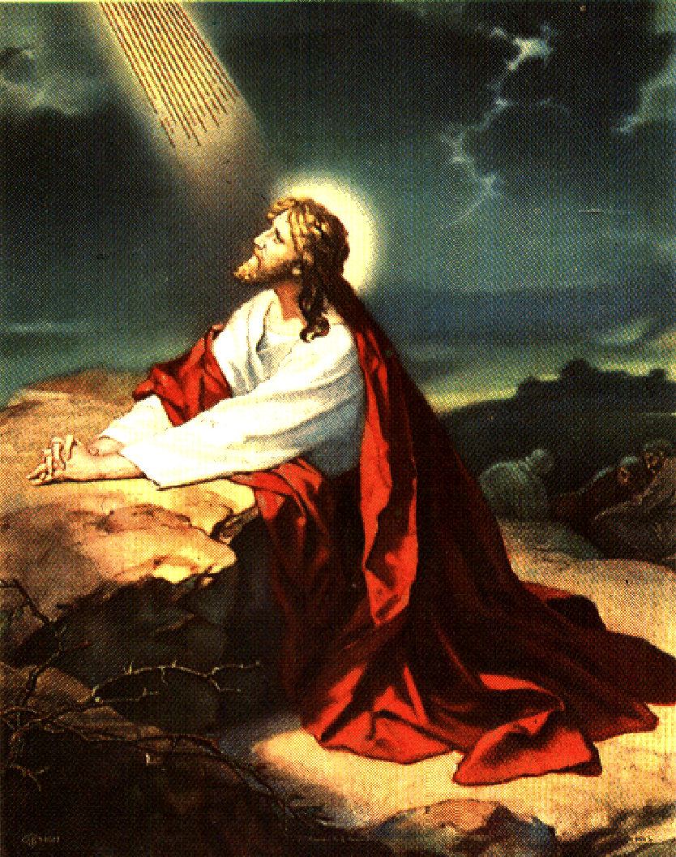  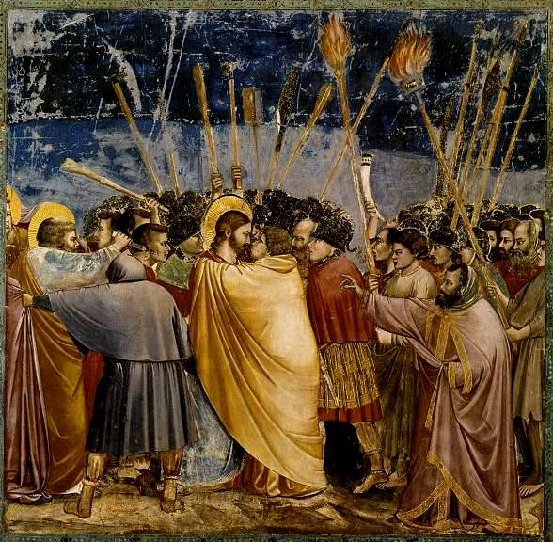  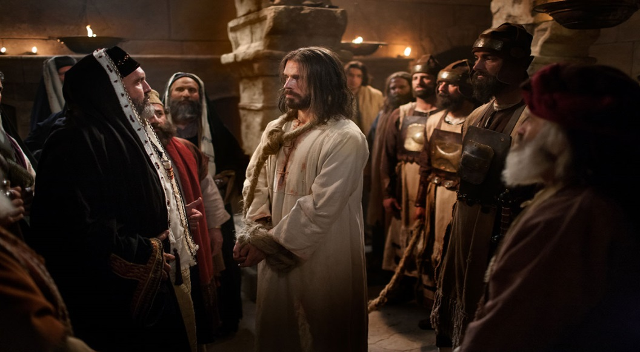 | - Power of Love  - Humility.  - That is how the Lord Jesus Christ was powerful when He was arrested. Other facing the same situation could have been shaken with fear, while with the Lord, it was the opposite: He was not afraid but those who came to arrest Him were too scared to face Him, till He presented Himself to them saying, “ I am He”  - The power to heal the ear of the soldier.  - Why were the trials of the Jews done at night?  - Accusations did not upset the Lord Christ, neither did false witnesses. His silence was more powerful than words, it made them feel that their accusations and false witnesses were trifles .. They searched for another charge and implored Him to admit that He was Christ the Son of God. "I charge You on oath by the living God that You tell us whether You are the Christ, the Son of God .” He could have kept silent but He answered powerfully, "It is as you said. Nevertheless, I say to you hereafter you will see the Son of Man sitting at the Right Hand of the Power and coming on the clouds of heaven"
Friday | 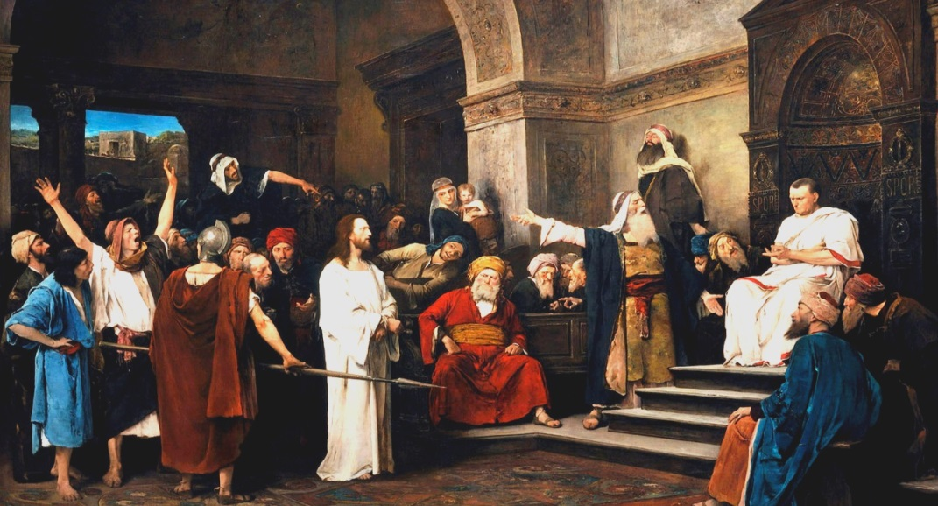 | No words were said to convince Pilate, but it was the Lord's silence and the power that radiated from Him. That governor  tried different tricks to set Him free and when he failed he washed his hands announcing his innocence of the blood of the  Lord Christ.
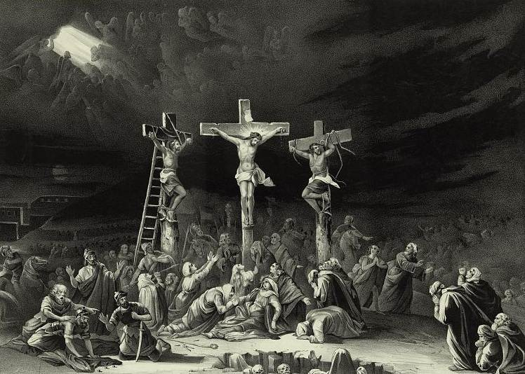

- Power of love to the degree of sacrificing Himself for us.
- Power to forgive those who hurt Him.
- Power to promise the right thief a place in heaven.
- Power over nature, the sun darkened, earthquake.
- Power to raise some saints from death who were seen.
- Power to make people believe even after his death; the centurion.

